**VISVESVARAYA TECHNOLOGICAL UNIVERSITY**

##### “Jnana Sangama”, Machhe, Belagavi, Karnataka-590 018

A Project Report On

**“Pesticide Sprinkler With IOT Based Security”**

###### Submitted in partial fulfillment of the requirements for the award of the degree of

**Bachelor of Engineering in**

**Electrical & Electronics Engineering**

*Submitted by*

**Bhoomika C P 4GW19EE005 Prakruthi K N 4GW19EE026 Rakshitha G 4GW19EE030**

**Vidyashree K 4GW19EE041**

### Under the Guidance of

**Mrs. Shilpashri V N**

### Assistant Professor Dept. of EEE, GSSSIETW

**DEPARTMENT OF ELECTRICAL & ELECTRONICS ENGINEERING**

**(Accredited by NBA, New Delhi, Validity from 01.06.2021 to 30.06.2024)**

**GSSS INSTITUTE OF ENGINEERING & TECHNOLOGY FOR WOMEN**

**(Affiliated to VTU, Belagavi, Approved by AICTE, New Delhi & Govt. of Karnataka)**

**K.R.S ROAD, METAGALLI, MYSURU-570016, KARNATAKA**

##### Accredited with Grade “A” by NAAC 2023

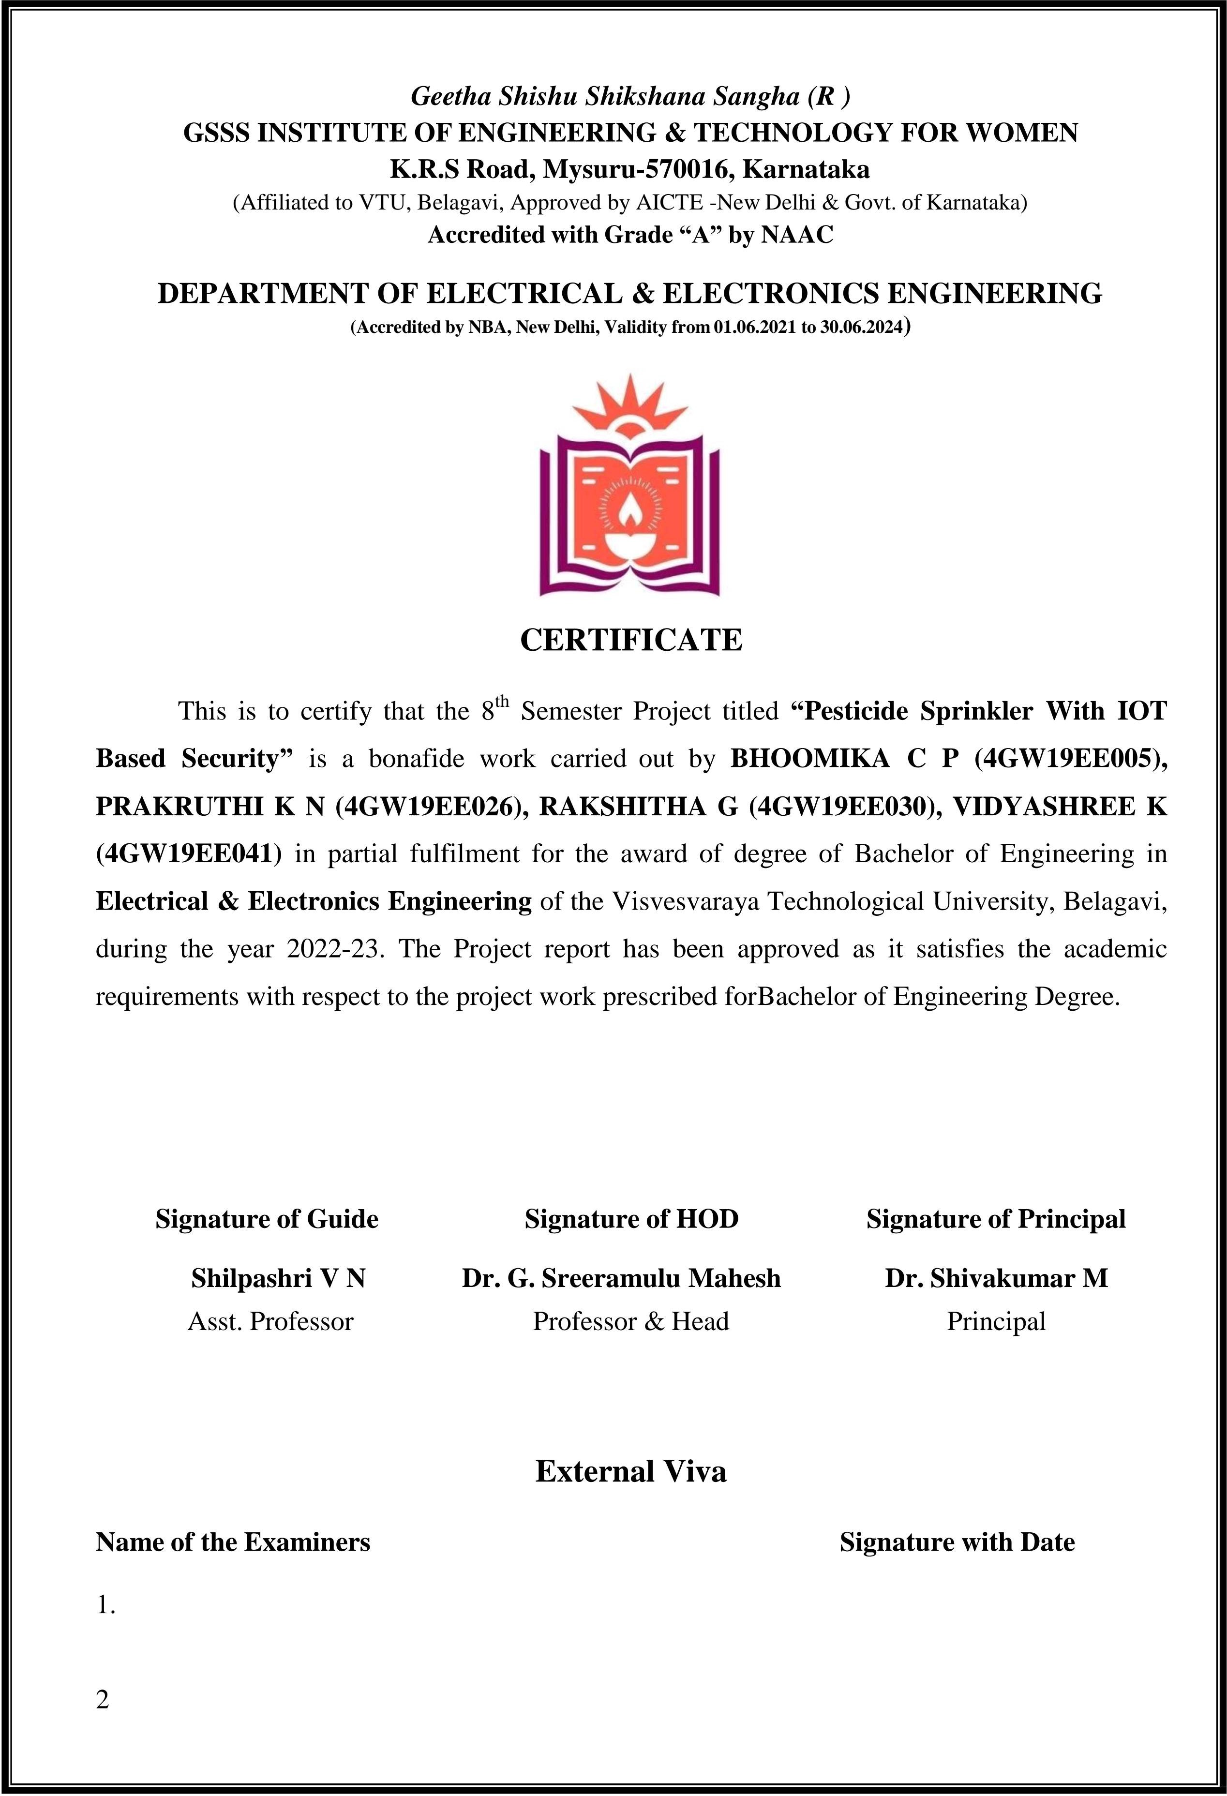

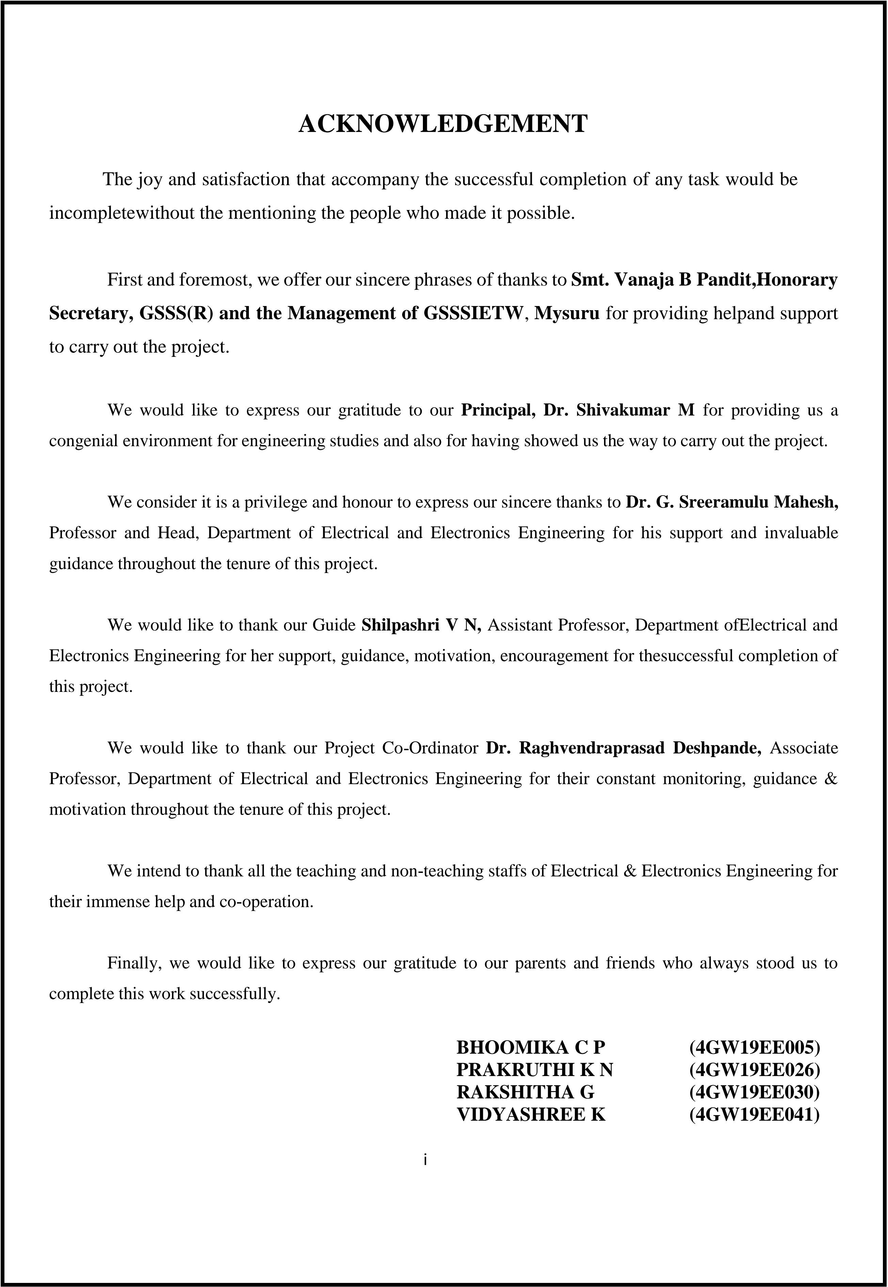

# ABSTRACT

Manual spraying of pesticides and herbicides to crops and weed inhibitors onto the field are quite laborious work to humans. Manual trimming of selected unwanted plants or harvested crops from the field is also difficult. The management of pest insects is the critical component of agricultural production especially in the fertigation based farm. Almost agricultural plants are damaged, weakened, or killed by insect pests especially. These results in reduced yields, lowered quality, and damaged plants or plant products that cannot be sold.. It is because the pesticide is a hazardous component that can be affected human health in the future if it exposed during manual spraying method especially in a closed area such as in the greenhouse. Our project proposes flexible, Remote Controlled, semi-automated spraying robot with some Degrees of Freedom in spatial movement, The robot is designed to spray pesticide/insecticide directly onto individual lesions minimizing wastage or excess chemical spraying, hence making the system cost effective and also environment friendly. It is designed to cut down undesired plants selectively by remotely controlling the start and stop of the mowing system. The flexible sprayer can be flexibly controlled in the greenhouse and outdoor environment such as open space farms. Besides, the proposed pesticide sprayer also can be used for various types of crops such as tomato, pineapples, vegetables and etc Alternatively, it also serves the purpose of maintaining lawns and sports field made of grass. The same system can be used for water spraying and mowing the grass to desired levels, leading to proper maintenance of the field.

**Keywords:** pesticides, fertigation, adjustable robotic spraying, ultrasonic sensors

**CONTENTS**

### CERTIFICATE

### ACKNOWLEDGEMENT i

ABSTRACT ii

CONTENTS iii

LIST OF FIGURES iv

|  |  |  |
| --- | --- | --- |
| **Chapter 1** | **Introduction** | 1-3 |
|  | 1.1 General |  |
|  | 1.2 Problem statement |  |
|  | 1.3 Objectives |  |
|  | 1.4 Scope of the project |  |
| **Chapter 2** | **Literature Survey** | 4-7 |
| **Chapter 3** | **Methodology** | 8-9 |
| **Chapter 4** | **Hardware requirements** | 10-15 |
| **Chapter 5** | **Software requirements** | 16-22 |
| **Chapter 6** | **Results and discussion** | 23-24 |
| **Chapter 7** | **Conclusion and future work** | 25 |
| **References** |  | 26-27 |

**LIST OF FIGURES**

##### Figure Number Description Page No.

|  |  |  |
| --- | --- | --- |
| Figure 1.1 | Pesticide absorption percentage due to manual spraying | 2 |
| Figure 3.1 | Block diagram | 9 |
| Figure 3.2 | Circuit diagram | 9 |
| Figure 4.1 | Arduino UNO | 11 |
| Figure 4.2 | Car kit | 13 |
| Figure 4.3 | PIR sensor | 14 |
| Figure 4.4 | LN298 Motor driver | 15 |
| Figure 5.1 | Arduino IDE | 16 |
| Figure 5.2 | Blynk application | 18 |
| Figure 6.1 | Circuit connection and final model | 24 |
| Figure 6.2 | NodeMCU_car Application | 24 |

**CHAPTER -1 INTRODUCTION**

* 1. **General**

The agriculture sector is essential to India's economic and social development, with significant contributions to employment generation, food security, export earnings, and rural development. It employs around 50% of the country's workforce, contributes around 17-18% to GDP, and is the largest employer, providing livelihoods to millions of people. Additionally, it plays a vital role in ensuring food security and meeting the nutritional needs of the population and is a major contributor to the country's export earnings.

The existing pesticide sprayers in agriculture have a number of notable problems that can impact their effectiveness and sustainability. They may not be efficient in their application, which can result in uneven distribution of pesticides and ineffective pest control. Also, traditional sprayers often lack the necessary security features to prevent misuse or theft of pesticides, which can pose risks to both human health and security. These issues highlight the need for more advanced solutions, such as an IoT-based security system or pesticide sprinklers, which can address these problems and improve the overall effectiveness and sustainability of pesticide use in agriculture.

The use of pesticides in agriculture can have negative health effects on humans and the environment. Exposure to pesticides through inhalation, skin contact, or ingestion can cause various health problems, including acute poisoning, respiratory problems, cancer, birth defects, neurological disorders, and hormonal imbalances. Pesticides can also enter the food chain and accumulate in soil, water, and food, posing a risk to both humans and wildlife. Long-term exposure to low levels of pesticides can have a cumulative effect, increasing the risk of chronic diseases. To minimize the health effects of pesticides, farmers and pesticide handlers should follow safety guidelines, and governments should regulate the use of pesticides and promote sustainable agriculture practices.

Pesticides can be very harmful to human health. The chemicals in the pesticides can cause short-term or long-term health effects for humans. The short-term or acute effects include: Nausea, Dizziness, Diarrhea, Itching of the skin, Rashes, Blisters, Colds/Flu , etc., Long-term or chronic health effects include: Tumors , Cancer , Damage to the brain or nervous system, Infertility , Damage to certain organs of the body such as kidneys, lungs or liver etc.,

Pesticide sprinklers with IoT-based security systems are a new and innovative way to manage pest control and enhance crop growth in agriculture. A pesticide sprinkler with an IoT-based security system offers a smart and efficient approach to addressing this challenge. It uses IoT sensors to detect and analyze the growth of crops and the presence of pests and diseases. With this data, it can automatically trigger the spraying of pesticides and other chemicals only where and when necessary, which leads to precise and targeted application. Moreover, it can also send alerts to farmers if any issues are detected, such as malfunctioning or lack of pesticides, allowing them to take corrective actions in real-time. In short, the pesticide sprinkler with an IoT-based security system is a promising solution to improve the yield and quality of crops while minimizing the use of harmful chemicals and their impact on the environment.

The main motive of the project is to prepare a BOT that will be useful in the field of agriculture. Spraying pesticides is the main task in agriculture to save crops from pests and insects. Farmers nowadays are spraying pesticides manually, which causes many problems for the farmers. Usage of manual techniques can harm them, like lifting heavy tanks can cause harm to shoulders, skin diseases, and many more. India is agrarian economies and most of rural populations depend on agriculture to earn their livelihood. The farming methods at present are manual or semiautomatic with high involvement of laborers.

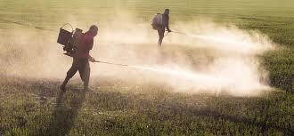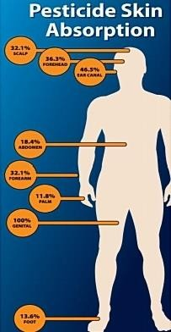

##### Fig 1.1 Pesticide absorption percentage due to manual spraying

* 1. **Problem statement**

Composed of chemicals that can control pests and diseases , pesticides are currently a widely used tool for pest and disease management. Human health and environmental issues related to pesticide handling are often pronounced because farmers and agricultural workers very often do not have adequate personal protective equipment and may also be unable to read labels with safety instructions due to illiteracy.

Pesticide manufacturers view their products as safe if used properly. However, product usage and handling as prescribed by manufacturers are often not realistic. Exposure effects can range from mild skin irritation to birth defects, tumors, genetic changes , blood and nerve disorders, endocrine disruption, coma or death.

* 1. **Objectives**
* To reduce the efforts taken by farmers.
* To design and implement the sprayer that sprays pesticides on crops.
* To speed up the pesticide spraying operation , hence increasing the production.
* To implement IOT system in agriculture.
  1. **Scope of the project**
* It is used for the application of liquid substances such as fertilizers and pesticides to plants during the crops growth cycle.
* The main scope of this project is to apply uniform dosage of pesticides to the target area.

**CHAPTER-2 LITERATURE SURVEY**

##### K. Marapalli, A. Bansode, P. Dundgekar and N. Rathod, “AIGER An Intelligent Vehicle for military purposes”.

This paper proposed that the Robots are built to perform special functions that cannot be handled by humans, or where conditions for humans to work are not certain and risky. Thus, these types of vehicles can perform the role that is difficult for humans. This motivated us to create a robot capable of performing risky tasks like border patrol and surveillance. The main purpose of this vehicle is to be controlled using hand gestures and travel long distance without any problem. This paper focuses on bringing together various technologies such as IOT, Software, Wireless communication, and mobile application. It uses GPS, HC-05 for communication and tracking the vehicle, Python/OpenCV with contour tracing and ESP32 Cam to find the enemies and obstacles. This paper presents a low-cost human-computer interaction device represented by Arduino glove to control RC car.

##### T. Akilan, S. Chaudhary, P. Kumari and U. Pandey, “Surveillance Robot in Hazardous Place Using IoT Technology”

This paper deals with human surveillance through the technology based on IoT featuring robotics using an Arduino UNO microcontroller that is controlled by a smartphone and a PC. The objective is to develop a spy robotic car which is suited to provide an act of continuous surveillance in hazardous environment. The robot is capable to record the real-time streaming in day time and night time as well through wireless camera. Those movements of the robot are controlled manually at the user end. This robot reduces human intervention directly in the hazardous place where continuous supervision and security is necessary. The complete system comprises of various sensors like PIR sensors, ultrasonic sensor, and gas sensor interfaced with Arduino board. Spy robot monitor the live streaming information and transfer it to the connected Arduino device.

##### J.Xiao et al., “Design of Ultrasonic Radar Detection System”

This paper proposed that To solve the problems of limited range and low measurement accuracy of traditional reversing radar, a high-precision radar detection system based on dual micro-controller units is designed. In this system, two STC89C52 single-chip microcomputers are used in Ceramic Insulators, Polymeric Insulators, Room Temperature Volcanizing silicone (RTV)-coated porcelain, Toughened glass and non- ceramic insulators, Silicone rubber, Glass insulatorsto control eight-channel ultrasonic sensors to carry out ranging to avoid blind area. Meanwhile, a temperature sensor is used to detect the environment temperature in real time, and temperature compensation ultrasonic wave velocity is applied to improve the measurement accuracy. In addition, 5 buttons are applied to set alarm threshold of buzzer which can control buzzer's frequency varies with different frequencies by different distances. Moreover, the design used LCD1602 and light-emitting diode for display and further warning. The test results show that the linear ranging distance of the system is 0.01~7 m, and the ranging accuracy can reach 0.01m.

##### Pratibha, R. Rajput, A. Yadav, A. S. Ansari, M. A. Husain and S. P. Singh, “Designing of Automatic Corridor Lighting System Using PIR Motion Sensor.”

Electrical energy increases its vast area day by day. Just like water it becomes necessary to save power for betterment of our future. So, an idea came into our minds why not we develop a technique for reducing the power demand by making corridor’s lights efficient. In this documentation we discuss the experiment which was implemented in Electrical Engineering department’s corridor of Rajkiya Engineering College Ambedkar Nagar, Uttar Pradesh, India. The main purpose of this experiment is to reduce the power consumption and make corridor lighting system to be more efficient. These experiments are mostly based on our observations that mainly college’s corridor is used when the class period is going on and human movements during these period and the remaining time corridors are empty but the lights in corridor is always turn ON till the college is not over.

##### A. Ramkumar, T. Karthick, C. V. Kumar, S. Rajendran and K. Rajesh, “Design and Development of E-Vehicle with Phone Control”.

This paper proposed that A vehicle is commonly described as any mobile equipment that is

controlled by a method that does not restrict its movement. This is also known as a radio control device or an IR controller because there is a cable between the controller and the car. A remote control vehicle that, unlike a robot, is always commanded by a person and does not take positive action on its own. Remote vehicle control is one of the most essential technologies in this industry. This paper focuses a e-vehicle capable to drive accurately at a destination location, navigating within that target region and return back to base station accurately and safely. Also, this paper proposes a e-vehicle is designed and its control can be carried out by Arduino via a cell phone.

##### Debajyothi Mukhopandadhyay, Megha Gupta, Tahesin Attar, Prajakta Chavan, “An Attempt to Develop an IOT based Vehicle Security System”

As the amount of urban vehicle grows rapidly, vehicle theft has become a shared concern for all citizens. Security and safety have always become a necessity for urban population. However, present anti-theft systems lack the tracking and monitoring function. Internet of things (IOT) has been governing the electronics era with cloud services dominating the ever-increasing electronics product segment. Thus, there is a need to develop a system for providing security to the vehicle from problems like theft and towing using IOT for security of automobiles and passengers. Our system proposes a novel security system based on wireless communication and a low cost Bluetooth module. This paper illustrates a model in which the GSM is used for sending messages. the user can control the engine/ignition and turn it off if needed.

##### Wai Mo Mo Khaing, Kyaw Thila, “Design and Implementation of Remote Operated Spy Robot Control System”

This paper proposed that the Spy robots are remotely controlled robots, equipped with a camera, transmitting video data to the intervention troop. They are made to small and compact enough to easily transport. In this paper, the project supposes a movable spy robot with a remote controller by using PIC 16F628A and PIC 16F877. The spy robot is made up of a wireless camera, an antenna, batteries and four movable wheels. The two different PICs are used to remotely control along wireless system and to control Spy robot. CCD camera is used to capture information surrounding the robot. A 4 bits LCD display is mounted on remote controller to view user command. To use the Spy robot in the dark area as night, the CCD is set up with LED

that connected by lighting circuit. Radio Frequency modules signals are used in wireless remote control system for transmitting and receiving wireless logic signals to control the motors of the Spy robot control system.

##### Diarah Reuben Samuel, Ojongbede,H.A, “Microcontroller Based Security System With Intruder Position”

This paper proposed that The microcontroller Based Security System with Intruder Position Display is a design that applies automated security system in homes, Industries, military etc.

The project will feature a system that will track the presence of an intruder in restricted area and also inform the user about the position of the intruder. This Project will be based on microcontroller and other electronic design to achieve the above stated purposes.

**CHAPTER-3 METHODOLOGY**

* The robot is made to travel in the farm and it is powered through batteries using a programming board and its direction is controlled by an Android application (blynk ).
* The spraying of pesticides which can be done with the help of pesticide sprinkling pump and is periodically sprayed whenever the process is on the spraying angle is kept exactly at 180**֯**. And the length of the spraying mouth can be extended as per the requirement .
* The system is focused on the design, development and the fabrication of the agricultural robot with pesticide spraying system in addition to security system using IOT.
* The problems associated with the manual operated spraying machine are rectified and a machine to overcome those problems is designed.
* Selection of the motor is a major problem because it depends on the torque required and weight to be pulled. The battery selection also places an important role .The required power is delivered to the system by the battery.
* The choice of materials for a vehicle is the first and most important factor for automotive design. In this we used Mild Steel bar alloy as a base material for chassis it will provide maximum strength and minimum deflection compared to other chassis material. Analyzed design of chassis is selected which has robust design and best suitable for agricultural works
* The selected Materials are fabricated by using permanent joints as well as temporary joints. All the components are fitted and connected as in electronic circuit.
* It is aimed more at an agricultural land by spraying long distance. The studies demonstrated that each stages have potential to be the most cost effective solution to perform well in agricultural land .

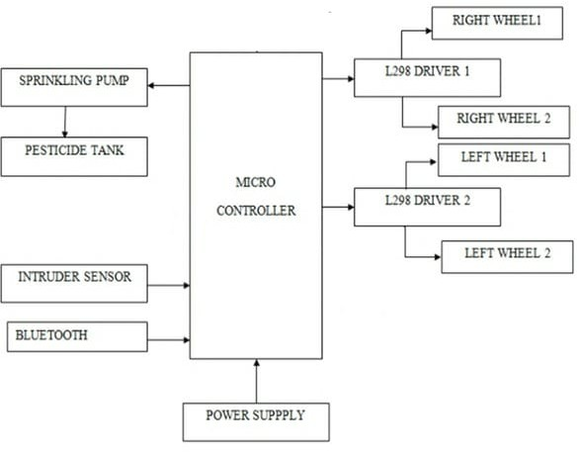

**Fig 3.1 Block Diagram**

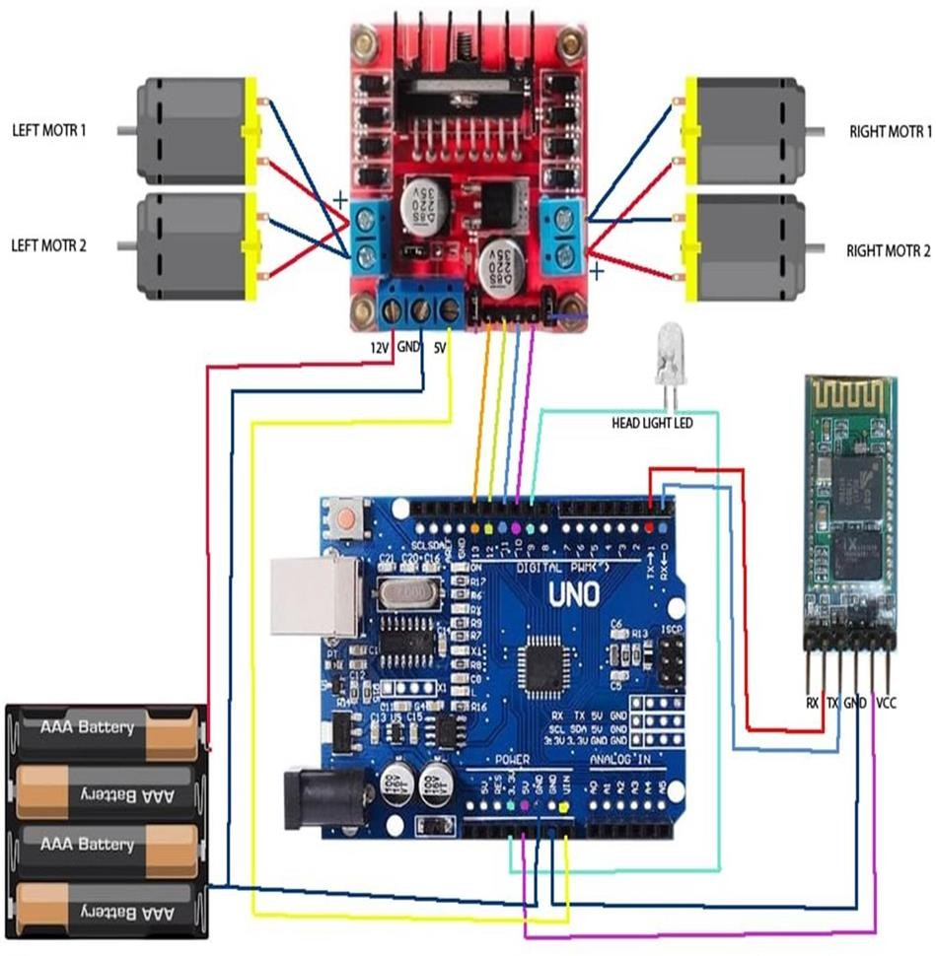

**Fig 3.2 Circuit Diagram**

**CHAPTER-4 HARDWARE REQUIREMENTS**

PESTICIDE SPRINKLER WITH IOT BASED SECURITY is a project that requires both hardware and software, so let’s see the hardware that this project needs. The following hardware components are the requirements for making of the device. Each component and their description are given below:

|  |  |  |  |
| --- | --- | --- | --- |
| **SL.NO** | **COMPONENT NAME** | **SPECIFICATION** | **NO. OF COMPONENT** |
| 01 | Arduino Board | Atmega 2560 | 1 |
| 02 | PIR | Infrared sensor | 1 |
| 03 | CAR kit | --- | 1 |
| 04 | DC motor | ESP8266 | 1 |
| 05 | LN298N Motor drivers |  | 1 |
| 06 | FTDI Module | SPST reset switch | 1 |
| 07 | Jumpers | DS18B20 | 1 |

#### Table 4.1

##### Arduino Board:

Arduino is a open-source hardware and software platform used to design and build electronic devices. The Arduino board consists of sets of analog and digital I/O (Input / Output) pins, which are further interfaced to bread board, expansion boards, and other circuits. Such boards feature the model, Universal Serial Bus (USB), and serial communication interfaces, which are used for loading programs from the computers. The Arduino Uno is a microcontroller board based on the ATmega328. It has 20 digital input/output pins (of which 6 can be used as PWM outputs and 6 can be used as analog inputs), a 16 MHz resonator, a USB connection, a power jack, an in-circuit system programming (ICSP) header, and a reset button.

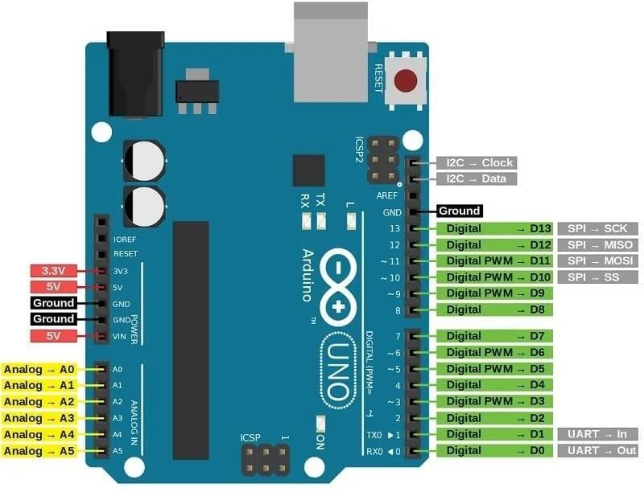

##### Fig 4.1 Arduino UNO

**General Pin Functions:**

* **LED**: There is a built-in LED driven by digital pin 13.When the pin is high value, LED is on, when the pin is low, it is off.
* **VIN**: The input voltage to the Arduino board when it is using an external power source (as opposed to 5 volts from the USB connection or other regulated power source). You can supply voltage through this pin, or, if supplying voltage via the power jack, access itthrough this pin.
* **5V**: This pin outputs a regulated 5V from the regulator on the board. The board canbe supplied with power either from the DC power jack (7 - 20V), the USB connector (5V), or the VIN pin of the board (7-20V). Supplying voltage via the 5Vor 3.3V pins bypasses the regulator, and can damage the board.
* **3.3V**: A 3.3volt supply generated by the on-board regulator. Maximum current draw is 50mA.
* **GND**: Ground pins.
  + **IOREF**: This pin on the Arduino board provides the voltage reference with which the microcontroller operates. A properly configured shield can read theIOREF pin voltage and select the appropriate power source, or enable voltage translators on the outputs to work with the 5V or 3.3V.
  + **Reset**: Typically used to add a reset button to shields that block the one on the board.

**Special pin functions:**

* + Each of the 14 digital pins and 6 analog pins on the Uno can be used as an input or output, under software control They operate at 5 volts. Each pin can provide or receive 20 mA as the recommended operating condition and has an internal pull-up resistor of 20-50K ohm. A maximum of 40mA must not be exceeded on any I/O pin to avoid permanent damage to the microcontroller.
  + **The External interrupts**: pins 2 and 3. These pins can be configured to trigger an interrupt on alow value, a rising or falling edge, or a change in value.

Uno has 6 analog inputs, labeled A0 through A5; each provides 10 bits of resolution. By default, they measure from ground to 5 volts, though it is possible to changethe upper end of the range using the AREF pin and the analog Reference() function.

* + **Serial** / [UART](https://en.wikipedia.org/wiki/UART): pins 0 (RX) and 1 (TX). Used to receive (RX) and transmit (TX) TTL serial data. These pins are connected to the corresponding pins of the ATmega8U2 USB-to-TTL serial chip.
  + [**PWM**](https://en.wikipedia.org/wiki/Pulse-width_modulation) (pulse-width modulation): pins 3, 5, 6, 9, 10, and 11. Can provide 8-bitPWM output with the analog Write () function.
  + `Serial Peripheral Interface): pins 10 (SS), 11 (MOSI), 12 (MISO), and 13(SCK). These pins support SPI communication using the SPI library.
  + **TWI** (two-wire interface) / [I²C](https://en.wikipedia.org/wiki/I%C2%B2C): pin SDA (A4) and pin SCL (A5). Support TWI communication using the Wire library.
  + **AREF** (analog reference): Reference voltage for the analog inputs.

**Specifications of Arduino:**

* The operating voltage is 5V.
* The recommended input voltage will range from 7v to 12V.
* The input voltage ranges from 6v to 20V.
* Digital input/output pins are 14.
* Analog i/p pins are 6.
* DC Current for each input/output pin is 40 mA.
* DC Current for 3.3V Pin is 50 mA.
* Flash Memory is 32 KB.

##### CAR KIT

This is Four Wheel DIY Smart Robot Car Chassis Kit is the perfect mechanical platform for your robotics projects. All of the hardware and mechanical components needed to make your robot are included in this kit, including motors, wheels, chassis, nuts & bolts, and more. Simply connect your electronics (Arduino/Raspberry Pi and Motor Driver) and begin programming your robot. It has a big surface area with predrilled holes for installing sensors and electronics according to your needs. This robot chassis allows you to quickly prepare your mechanical platform. Instead of making your own chassis, you can focus your time and effort on programming your robot.

Wheeled Robots are the most common robots because they are simple to create, maintain, and operate. This kit is the simplest robot platform to construct and programme. Beginners and even experts can use this kit. This Two Wheel DIY Smart Robot Car Chassis Kit is less expensive,and it's easy to assemble, maintain, and programme. In comparison to the 3 wheeled Kit, our 4 wheeled Kit allows you to drive fast, carry more weight, and carry a larger load. This kit can be used to make line- following robots, obstacle-avoidance robots, maze solvers, Bluetooth controlled robots, fire fighting robot and other robots.

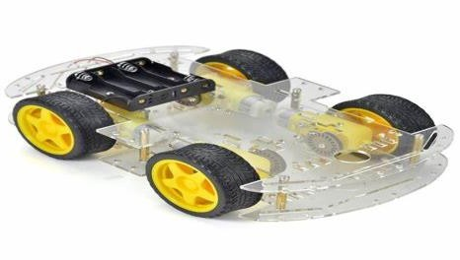

**Fig 4.2 Car kit**

##### PIR SENSORS

A passive infrared (PIR) sensor recognizes infrared light emitted from nearby objects. You may assume that ―passive‖ IR sensors mean these devices are less complicated than their active counterparts, but you’d be mistaken. A passive IR sensor’s functionality may be more difficult to understand.

##### PIR Sensor Functions:

First, realize that everything — humans, animals, even inanimate objects — emit a certain amount of IR radiation. How much IR radiation they emit relates to the body or object’s warmthand material makeup. Humans can’t see IR, but we’ve designed electronic detection devices to pick up these signals. PIR sensors are used in thermal sensing applications, such as security andmotion detection. They are commonly used in security alarms, motion detection alarms, and automatic lighting applications.

Passive infrared (PIR) sensors use a pair of pyroelectric sensors to detect heat energy in the surrounding environment. These two sensors sit beside each other, and when the signal differential between the two sensors changes (if a person enters the room, for example), the sensor will engage. That may mean it triggers an alarm, notifies authorities, or maybe turns on afloodlight. IR radiation focuses on each of the two pyroelectric sensors using a series of lenses constructed as the sensor’s housing. These lenses widen the device’s sensing area.

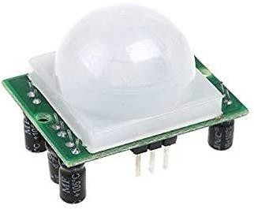

##### Fig 4.3 PIR Sensor

##### LN298 MOTOR DRIVER

This is a high-power motor driver module for driving DC and stepper motors. This module consists of an L298 motor driver IC and a 78M05 5V regulator. It can control up to 4 DC motors,or 2 DC motors with directional and speed control. It is designed to provide bidirectional drive currents of up to 4A at voltages from 2.5 V to 46 V.

The L298N is an integrated monolithic circuit in a 15- lead Multi watt and PowerSO20 packages. It is a high voltage, high current dual full-bridge driver de-signed to accept standard TTL logic level sand drive inductive loads such as relays, solenoids, DC and stepping motors. Two enable inputs are provided to enable or disable the device independently of the in-put signals .The emitters of the lower transistors of each bridge are connected together rand the corresponding external terminal can be used for the connection of an external sensing resistor. An additional Supply input is provided so that the logic works at a lower voltage.

##### Features & Specifications:

* Driver Model: L298N 2A
* Driver Chip: Double H Bridge L298N Motor Supply Voltage (Maximum): 46VMotor Supply Current (Maximum): 2A Driver Voltage: 5-35V
* Driver Current: 2A Maximum Power (W): 25W

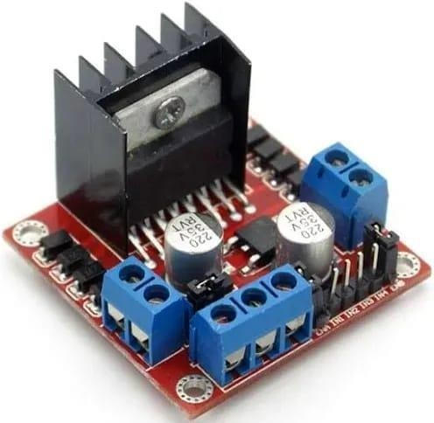

##### Fig 4.4 LN298 MOTOR DRIVER

**CHAPTER-5 SOFTWARE REQUIREMENTS**

##### ARDUINO IDE

Arduino is a type of computer software and hardware company that offers open-source environment for user project and user community that intends and fabricates microcontroller based inventions for construction digital devices and interactive objects that can sense andmanage the physical world. For programming the microcontrollers, the Arduino proposal provides an software application or IDE based on the Processing project, which includes C, C++ and Java programming software. It also support for embedded C, C++ and Java programming software.



##### Fig 5.1 Arduino IDE

Arduino is an open-source computer hardware and software company, project and user community that designs and manufactures microcontroller-based kits for building digital devices and interactive objects that can sense and control the physical world. The boards feature serial communications interfaces, including USB on some models, for loading programs from personal computers. For programming the microcontrollers, the Arduino platform provides an integrated development environment (IDE) based on the Processing project, which includes support for C, C++ and Java programming languages.

An Arduino board consists of an Atmel 8, 16 or 32-bit AVR microcontroller with complementary components that facilitate programming andincorporation into other circuits. An important aspect of the Arduino is its standard connectors, which lets users connect the CPU board to a variety of interchangeable add-on modules knownas shields. Some shields communicate with the Arduino board directly over various pins, but many shields are individually addressable via an I²C serial bus so many shields can be stacked and used in parallel. Official Arduinos have used the mega AVR series of chips, specifically the ATmega8, ATmega168. An Arduino's microcontroller is also pre-programmed with a bootloader that simplifies uploading of programs to the on-chip flash memory, compared with other devices that typically need an external programmer. This makes using an Arduino more straightforward by allowing the use of an ordinary computer as the programmer. Currently, opti boot loader is the default boot loader installed on Arduino UNO.

**Blynk**

Blynk is an IoT platform for iOS or Android smartphones that is used to control Arduino, Raspberry Pi and Node_MCU via the Internet. This application is used to create a graphical interface or human machine interface (HMI) by compiling and providing the appropriate address on the available widgets.

Blynk was designed for the Internet of Things. It can control hardware remotely, it can display sensor data, it can store data, visualize it and do many other cool things. Blynk App: – It allows you to create amazing interfaces for your projects using various widgets which are provided.

Blynk Server:- It is responsible for all the communications between the smartphone andhardware. You can use the Blynk Cloud or run your private Blynk server locally. It's open-source, could easily handle thousands of devices and can even be launched on a Raspberry Pi.

Blynk Libraries:- It enables communication, for all the popular hardware platforms, with the server and process all the incoming and outcoming commands.

The process that occurs when someone presses the Button in the Blynk application is that the data will move to Blynk Cloud, where data magically finds its way to the hardware that has been installed. It works in the opposite direction and everything happens in a blink of an eye.

The main focus of the Blynk platform is to make it super-easy to develop the mobile phone application.

As you will see in this course, developing a mobile app that can talk to your Arduinois as easy as dragging a widget and configuring a pin. With Blynk, you can control an LED or a motor from your mobile phone with literally zero programming.

You can use it to monitor the soil humidity of your vegetable garden and turn on the water, or open up your garage door, with your phone. You can also use to control smart furniture that can learn from your routines, or embed IoT and AI to traditional industrial products such as a boiler, or for improving the integrity and safety of oilfields. Blynk is free to use for personal use and prototyping. Their business model generates profits by selling subscriptions to businesses that want to publish Blynk-powered apps for their hardware products or services. Let’s take a closer look at each component of the Blynk Platform.

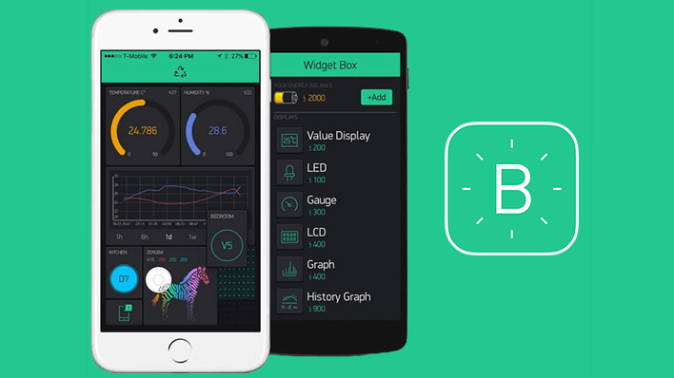

##### Fig 5.2 Blynk application

**Payload coding :**

|  |  |  |  |
| --- | --- | --- | --- |
| #define ENA | 14 | // Enable/speed motors Right | GPIO14(D5) |
| #define ENB | 12 | // Enable/speed motors Left | GPIO12(D6) |
| #define IN_1 | 15 | // L298N in1 motors Right | GPIO15(D8) |
| #define IN_2 | 13 | // L298N in2 motors Right | GPIO13(D7) |
| #define IN_3 | 2 | // L298N in3 motors Left | GPIO2(D4) |
| #define IN_4 | 0 | // L298N in4 motors Left | GPIO0(D3) |

#include <ESP8266WiFi.h> #include <WiFiClient.h>

#include <ESP8266WebServer.h>

String command; //String to store app command state. int speedCar = 800; // 400 - 1023.

int speed_Coeff = 3;

const char* ssid = "NodeMCU Car"; ESP8266WebServer server(80); void setup() { pinMode(ENA,OUTPUT); pinMode(ENB,OUTPUT); pinMode(IN_1,OUTPUT); pinMode(IN_2,OUTPUT); pinMode(IN_3,OUTPUT); pinMode(IN_4,OUTPUT); Serial.begin(115200);

// Connecting WiFi WiFi.mode(WIFI_); WiFi.softAP(ssid);

Serial.print("AP IP address: ");

Serial.println(myIP);

// Starting WEB-server

server.on ( "/", HTTP_handleRoot ); server.onNotFound ( HTTP_handleRoot ); server.begin();

}

void goAhead(){ digitalWrite(IN_1, LOW); digitalWrite(IN_2, HIGH); digitalWrite(IN_3, LOW); digitalWrite(IN_4, HIGH);

}

void goBack(){ digitalWrite(IN_1, HIGH); digitalWrite(IN_2, LOW); digitalWrite(IN_3, HIGH); digitalWrite(IN_4, LOW);

}

server.arg("State"); if (command

== "F") goAhead();

else if (command == "B")

else if (command == "I") goAheadRight(); (command == "1") speedCar = 470; else if (command == "2")

else if (command == "3")

else if (command == "S") stopRobot();

}

**Camera coding** #include "esp_camera.h" #include <WiFi.h>

//

// WARNING!!! PSRAM IC required for UXGA resolution and high JPEG quality

// Ensure ESP32 Wrover Module or other board with PSRAM is selected

// Partial images will be transmitted if image exceeds buffer size

//

// Select camera model

//#define CAMERA_MODEL_WROVER_KIT // Has PSRAM

//#define CAMERA_MODEL_M5STACK_PSRAM // Has PSRAM//#define CAMERA_MODEL_ESP_EYE // Has PSRAM

//#define CAMERA_MODEL_M5STACK_V2_PSRAM // M5Camera version B Has PSRAM

//#define CAMERA_MODEL_M5STACK_WIDE // Has PSRAM

//#define CAMERA_MODEL_M5STACK_ESP32CAM // No PSRAM

#define CAMERA_MODEL_AI_THINKER // Has PSRAM

//#define CAMERA_MODEL_TTGO_T_JOURNAL // No PSRAM void startCameraServer();

void setup() { Serial.begin(115200); Serial.setDebugOutput(true); Serial.println(); camera_config_t config;

config.ledc_channel = LEDC_CHANNEL_0; config.ledc_timer = LEDC_TIMER_0; config.pin_d0 = Y2_GPIO_NUM; config.pin_d1 = Y3_GPIO_NUM; config.pin_d2 = Y4_GPIO_NUM; config.pin_d3 = Y5_GPIO_NUM; config.pin_sscb_sda = SIOD_GPIO_NUM; config.pin_sscb_scl = SIOC_GPIO_NUM;

config.pin_pwdn = PWDN_GPIO_NUM; config.pin_reset = RESET_GPIO_NUM; config.xclk_freq_hz = 20000000; config.pixel_format = PIXFORMAT_JPEG;

// if PSRAM IC present, init with UXGA resolution and higher JPEG quality

// for larger pre-allocated frame buffer. if(psramFound()){

config.frame_size = FRAMESIZE_UXGA; config.jpeg_quality = 10;

config.fb_count = 2;

} else {

config.frame_size = FRAMESIZE_SVGA; config.jpeg_quality = 12;

config.fb_count = 1;

}

while (WiFi.status() != WL_CONNECTED) { delay(500);

Serial.print(".");

}

Serial.println(""); Serial.println("WiFi connected"); startCameraServer();

Serial.print("Camera Ready! Use 'http://"); Serial.print(WiFi.localIP()); Serial.println("' to connect");

}

void loop() {

// put your main code here, to run repeatedly: delay(10000);

}

**CHAPTER- 6 RESULTS AND DISCUSSION**

We have conducted some experiments to know the quality of performance of all the modules. It has been tested on more than one way.In order to evaluate the performance of the system, several trials were performed on the robot. We have evaluated different functions that are to be performed by the robot.

The functions are listed below:

1. Pesticide spraying
2. Mowing operation
3. Robot’s movement
4. Battery performance

Pesticide spraying Pesticide spraying has two aspects,

1. The distances and areas covered by the actuation setup
2. The distances and areas covered by the sprayer

The distances and areas covered by the actuation setup: The position of the Nozzle is with the help of the combination of Horizontal and Vertical actuation, this combination is referred as the actuation setup. This is done so as to increase the work volume of the robot. The actuation setup is designed in such a way that it has 4 Degrees of Freedom, viz

However, agriculture robots remain experimental and far from being implemented on large operational scales. The paper investigated the possible reasons for this phenomena, by continuing the review of agriculture robots, only this time focusing on practicality and feasibility. Upon extensive review and analysis, it was known that practical agriculture robots rely not only on advances in robotics, but also on the presence of a support infrastructure.

In the proposed method, the power source is the 12V battery. The 2 DC motors are controlling the BOT to move in forward, backward, left and right directions, a submersible pump for pesticide spraying and an intruder detection system.

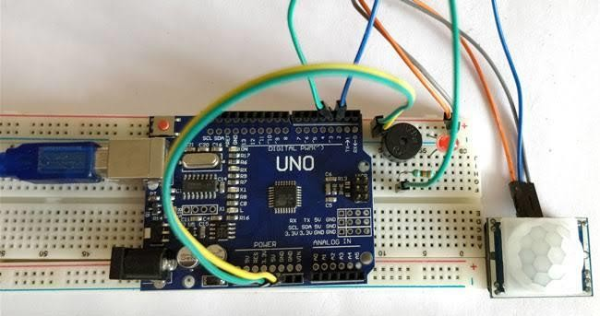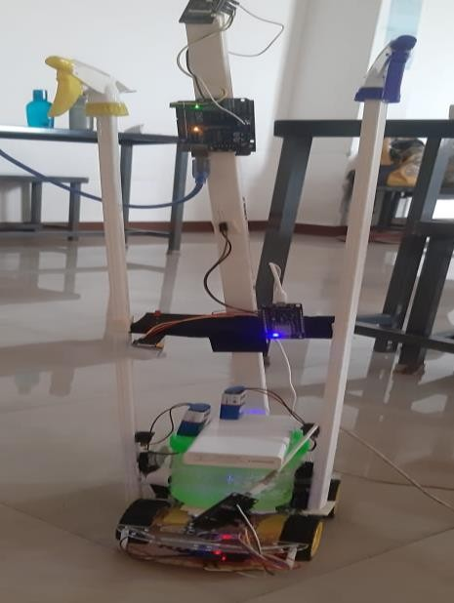

##### Fig 6.1 Circuit connection and final model

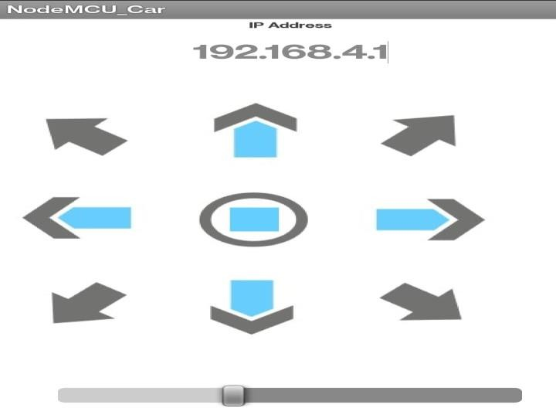

##### Fig 6.2 NodeMCU_car Application

**CHAPTER 7 CONCLUSION AND FUTURE WORK**

The prescribed robot and spraying method enable to play out the spraying undertaking profitably and financially. The central duty of this project is to structure up a novel spraying device that ensures full incorporation of the recognized article with least shower. Pesticide application is decreased by spraying every goal independently. This is cultivated by planning the spraying device toward the point of convergence of the goal and setting the thing detachment of the spraying as demonstrated by the shape and size of the goal. A sharp mechanical structure for spraying pesticides in cultivation field and for controlling the robot by the use of a remote choice rather than manual completion of yields shower tests, reduces the prompt prologue to pesticides and the human body, moreover decrease pesticide harm to people, and improve age adequacy. There can be diverse landscape and statures of yields for the spraying activity tests that demonstrates that a viable, portable robot, and gives the better splash impact at the workplace, for example, its low costs, simplicity of dealing with and simple support and different qualities of people with an expansive market in rural creation.

Mechatronics is playing an enormous role in agricultural production and management. There is a desire for autonomous and timesaving technology in agriculture to possess efficient farm management. The researchers are now aiming towards different types of farming parameters to style autonomous multipurpose agricultural robots because of traditional farm machineries and topological dependent. Till date the multipurpose agricultural robots have been researched and developed mainly for harvesting, fertilizer spraying, picking fruits, sowing, solar energy and monitoring of crops. Robots like these are brilliant replacements for manpower to a better extent as they deploy unmanned sensors and machinery systems. The agricultural benefits of development of these autonomous and intelligent robots are to improve repetitive precision, efficiency, reliability and minimization of soil compaction and chemical utilization. The robots have the potential of multitasking, sensory measures, idle operation as well working in odd operating conditions. The study on multipurpose agricultural robot system had been done using model structure design along with various precision farming machineries.

**References**

[1]. K. Marapalli, A. Bansode, P. Dundgekar and N. Rathod, “AIGER An Intelligent Vehicle for Military Purpose,” 2021 7th International Conference on Advanced Computing and Communication Systems (ICACCS), 2021, pp. 1052-1057, doi:10.1109/ICACCS51430.2021.9441998.

[2]. T. Akilan, S. Chaudhary, P. Kumari and U. Pandey, “Surveillance Robot in Hazardous Place Using IoT Technology,” 2020 2nd International Conference on Advances in Computing, Communication Control and Networking (ICACCCN), 2020, pp. 775-780, doi: 10.1109/ICACCCN51052.2020.9362813.

[3]. T. Akilan, S. Chaudhary, P. Kumari and U. Pandey, “Surveillance Robot in Hazardous Place Using IoT Technology,” 2020 2nd International Conference on Advances in Computing, Communication Control and Networking (ICACCCN), 2020, pp. 775-780, doi: 10.1109/ICACCCN51052.2020.9362813.

[4]. J. Xiao et al., “Design of Ultrasonic Radar Detection System,” 2021 IEEE 15th International Conference on Electronic Measurement & Instruments (ICEMI), 2021, pp. 471-475, doi: 10.1109/ICEMI52946.2021.9679522.

[5]. Pratibha, R. Rajput, A. Yadav, A. S. Ansari, M. A. Husain and S. P. Singh, “Designing of Automatic Corridor Lighting System Using PIR Motion Sensor,” 2021 International Conference on Control, Automation, Power and Signal Processing (CAPS), 2021, pp. 1-6, doi: 10.1109/CAPS52117.2021.9730730.

[6]. A. Ramkumar, T. Karthick, C. V. Kumar, S. Rajendran and K. Rajesh, “Design and Development of E-Vehicle with Phone Control,” 2021 Second International Conference on Electronics and Sustainable Communication Systems (ICESC), 2021, pp. 320-323, doi: 10.1109/ICESC51422.2021.9532622.

[7]. Pratibha, R. Rajput, A. Yadav, A. S. Ansari, M. A. Husain and S. P. Singh, "Designing of Automatic Corridor Lighting System Using PIR Motion Sensor," 2021 International Conference on Control, Automation, Power and Signal Processing (CAPS), Jabalpur, India, 2021, pp. 1-6, doi: 10.1109/CAPS52117.2021.9730730.

[8]. H. Gami, "Smart Motion Sensor Design for Energy Saving and Surveillance," 2022 2nd International Conference on Advance Computing and Innovative Technologies in Engineering

(ICACITE), Greater Noida, India, 2022, pp. 1-4, doi: 10.1109/ICACITE53722.2022.9823794.

[9]. K. C. Sahoo and U. C. Pati, "IoT based intrusion detection system using PIR sensor," 2017 2nd IEEE International Conference on Recent Trends in Electronics, Information & Communication Technology (RTEICT), Bangalore, India, 2017, pp. 1641-1645, doi: 10.1109/RTEICT.2017.8256877.

[10]. H. Nagdewani and P. S. Mehra, "A Complete Internet of Things based Home Security System," 2022 Second International Conference on Computer Science, Engineering and Applications (ICCSEA), Gunupur, India, 2022, pp. 1-5, doi: 10.1109/ICCSEA54677.2022.9936168.

[11]. H. T. Sukmana, M. G. Farisi and D. Khairani, "Prototype utilization of PIR motion sensor for real time surveillance system and web-enabled lamp automation," 2015 IEEE Asia Pacific Conference on Wireless and Mobile (APWiMob), Bandung, Indonesia, 2015, pp. 183-187, doi: 10.1109/APWiMob.2015.7374968.

### Project ID: 11

**DEPARTMENT OF ELECTRICAL AND ELECTRONICS ENGINEERING**

**Participation Certiﬁcate**

This is to certify that

**Bhoomika C P** of **GSSSIETW**

**has successfully presented project work entitled Pesticide sprinkler with IOT based security**

in the “Pioject Exhibition Shakthistaavaia-2023**”** Organized by Department of Electrical

and Electronics Engineering, GSSS Institute of Engineering and Technology For Women, Mysuru, in association with IEEE PES Student Chapter, Bangalore Section, on **26th April 2023.**

**HOD-EEE**



**Dr. G Sreeramulu Mahesh**

**Principal**

**Dr. Shivakumar M**

### Project ID: 11

**DEPARTMENT OF ELECTRICAL AND ELECTRONICS ENGINEERING**

**Participation Certiﬁcate**

This is to certify that

**Prakruthi K N**

of

**GSSSIETW**

**has successfully presented project work entitled Pesticide sprinkler with IOT based security**

in the “Pioject Exhibition Shakthistaavaia-2023**”** Organized by Department of Electrical

and Electronics Engineering, GSSS Institute of Engineering and Technology For Women, Mysuru, in association with IEEE PES Student Chapter, Bangalore Section, on **26th April 2023.**

**HOD-EEE**



**Dr. G Sreeramulu Mahesh**

**Principal**

**Dr. Shivakumar M**

### Project ID: 11

**DEPARTMENT OF ELECTRICAL AND ELECTRONICS ENGINEERING**

**Participation Certiﬁcate**

This is to certify that

**Rakshitha G** of **GSSSIETW**

**has successfully presented project work entitled Pesticide Sprinkler with IOT Based Security**

in the “Pioject Exhibition Shakthistaavaia-2023**”** Organized by Department of Electrical

and Electronics Engineering, GSSS Institute of Engineering and Technology For Women, Mysuru, in association with IEEE PES Student Chapter, Bangalore Section, on **26th April 2023.**

**HOD-EEE**



**Dr. G Sreeramulu Mahesh**

**Principal**

**Dr. Shivakumar M**

### Project ID: 11

**DEPARTMENT OF ELECTRICAL AND ELECTRONICS ENGINEERING**

**Participation Certiﬁcate**

This is to certify that

**Vidyashree K** of **GSSSIETW**

**has successfully presented project work entitled Pesticide sprinkler with IOT based security**

in the “Pioject Exhibition Shakthistaavaia-2023**”** Organized by Department of Electrical

and Electronics Engineering, GSSS Institute of Engineering and Technology For Women, Mysuru, in association with IEEE PES Student Chapter, Bangalore Section, on **26th April 2023.**

**HOD-EEE**



**Dr. G Sreeramulu Mahesh**

**Principal**

**Dr. Shivakumar M**

